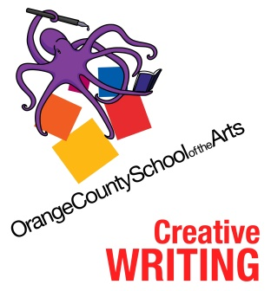

OCSA Creative Writing
Conservatory Calendar 2021-22
(subject to change)

PAC Meeting – Welcome to CW Fri., Aug. 20, 10am, Zoom
*Open Mic Night: Senior Spotlight Tues. Sept 14, 6-8 pm, SH, $1 Pizza @5pm!
Used Book Sale Sept. 28-Oct. 1, lunch & 7th blk., SH steps
PAC Meeting – RAT & Scarefest Thur., Sept. 16, 10am, Zoom
Read-A-Thon Fri., Oct. 1, 2 p.m. – 8 p.m., SH
Open Mic Night: Horror Spotlight Thur., Oct 14, 6-8 pm, SH, $1 Pizza @5pm!
Meet the Team Wed., Oct. 27, 5 p.m. DMS 101
& Scarefest! Wed., Oct. 27, 6 p.m. SH
Open Mic Night: Junior Spotlight Tues., Nov. 16, 6-8 pm, SH, $1 Pizza @5pm!
Open Mic Night: Comedy/Song Night Tues., Jan. 25, 6-8 pm, SH, $1 Pizza @5pm!
Open Mic Night: Soph/Fresh Spotlight Thur., Feb. 14, 6-8 pm, SH, $1 Pizza @5pm!
Open Mic Night: Faculty Spotlight Wed., March 9, 6-8 pm, SH, $1 Pizza @5pm!
PAC Meeting – OC RYSE Thur., Feb. 10, 10am, Zoom
OC RYSE Saturday, March 12, 1 p.m. – 5 p.m. The Webb
AWP Writer’s Conference March 23-26, Philadelphia PA
WonderCon Fri., April 1, Anaheim Convention Ctr.
LA Times Festival of Books TBD (Sat., April 16?)
New Play Fest TBD (April 14-16?)
Frankencity Social Activism Collab. TBD
PAC Meeting – Showcase & Awards Thur., Apr. 21, 10am, Zoom
Showcase Tues., May 17, 6 pm, SH
CW Awards Night & Senior Reading Thur., May 19, 6 pm, SH

*All Open Mic Nights are free to all. Symphony Hall (SH) The readings begin at 6 p.m. Refreshments start at 5 p.m. Volunteers and donations are needed for these and every event.

Parent Action Committee (PAC) meeting dates TBD. For both, contact: kncreations@cox.net; Jeannette Soumbasakis, soumbafam@gmail.com.

